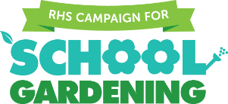
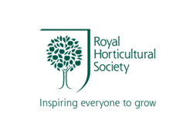

RHS Garden Wisley - Scarecrow Competition 2019

Spectacular Plant Discoveries

Application Pack and Design Submission

If you would like to take part in the competition, please complete this form and send it to us with your scarecrow design. Please attach a pdf of your final drawing and design idea to the email, together with a short explanation of your chosen discovery.

Please return your application by email to learning@rhs.org.uk with ‘Scarecrow Competition’ as the subject by 5pm on Monday 25 March 2019

Name of school or group:

Full address of school or group:

Contact name:

Contact telephone number:

Contact mobile number:

Email address:

Age category:

Ages 2-11 years

Ages 11-16 years

SEN groups (all ages)

Scarecrow Competition Design Template

School name:

Category: Ages 2-11 years Ages 11-16 years SEN groups (all ages)

Our chosen discovery is ............................................................................................................. ........................................................................................................................................................................................................................................................................................................
You do not have to use this design template page. You may prefer to submit your entry by attaching details of your discovery and scans of your own drawings to your application form.

